EHOP code quality assessment form

This is a form designed to help with the assessment of my (Brendan) research project for my bachelor of Computer Science and Engineering.
The purpose of this form is to gain insights into the quality of the code I’ve written for this project, the code in question is written in an Effect Handler Oriented Programming (EHOP) language, a brief explanation will be given later on.
The code to be assessed are a type checker and an interpreter for a functional toy language called Mini-ml¹. The following paragraph will briefly discuss the functionality of mini-ml (it is nearly identical to Simply Types Lambda Calculus for the people who know what that is).
This language contains 3 value types, numbers, booleans and value pairs.
Furthermore it allows you to bind variables with the `Let` and `Letrec` which each take three values, the name of the variable, the value of the variable and the piece of code in which the variable is in scope (let variable (be) value (in) body).
Lastly there are functions, denoted with the `Lambda` keyword, these functions can be used with the `Apply` keyword. There is also simple arithmetic manipulation (plus, minus, multiply) and ways to use booleans, in the form of if then else statements.
The `Null` value should never be found and is an error value.

Briefly on EHOP
The newly proposed programming paradigm of Effect Handler Oriented Programming (EHOP) is starting to see more practical research into its potential uses. EHOP languages look to bring a separation of concerns to the functional programming paradigm by introducing effects. Effects can do various things, they are, for example, used to handle the nonfunctional aspects of code, such as IO operations, state dependent operations and exceptions. This extra level of abstraction could be very useful for writing general code, as well as doing sand-boxing.

1. Mini-ml: https://www.cse.chalmers.se/edu/year/2018/course/DAT350/Kahn.pdf

On Koka
Functions are denoted with the `fun` keyword, followed by the function name, its input variables and types between braces. Then a colon and the effects the function requires between pointy braces and the return type.
Effects are denoted with the `effect` keyword, effects always provide functions with a set of functions and/or values whose type signatures are defined by the effect (though these type definitions can be polymorphic, which is the case in my `scope` effect type).
The effect is usually accompanied by one or more effect handlers, these are functions who implement the functionality (functions and/or values) of the effect in question.
Mock examples of both are shown bellow.
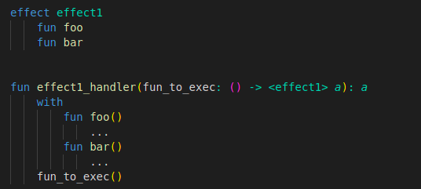

Effects can be implemented by using the `with` keyword. This can be done for individual functions/variables (as shown above), but can also be done for a whole effect at once when effect handler functions are used as shown bellow.
Furthermore, in Koka, you can pass a functions first variable by using the dot notation as you can see in the second example of a main function. These two main functions are identical and compile to the exact same code. (this is mostly useful when calling multiple functions over each others output, e.g. `fun.show.print`)
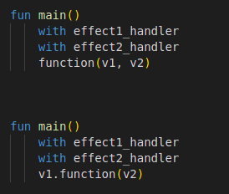

Effect handlers also automatically get passed between functions, so if a function recursively calls itself then it doesn’t need to explicitly mention the effect handlers that are being passed with it. This is also the case if a function calls another function that uses the same (or a subset of) the effects for which handlers are present at the place where it is being called.

Questionnaire
The following questions are about the code on my github page (created for my bachelors final project)
https://github.com/BrendanMesters/Koka-Linter/tree/main
Questions | Answer:  strongly agree, agree, indifferent, disagree, strongly disagree
The structure of the code is clear, you can follow along with the logic and understand what is happening from a high level view.
Further explanation (if applicable):

The code is concise, the code doesn’t seem to do things without any good reason and
Further explanation (if applicable):

The code is neat, it isn’t difficult to read and there is little visual clutter
Further explanation (if applicable):

The code is neat, it isn’t difficult to read and there is little visual clutter
Further explanation (if applicable):

Effect handlers seem helpful for the clarity of the code
Further explanation (if applicable):

Effect handlers seem useful for the functionality of the code
Further explanation (if applicable):

